SIMATS ENGINEERING (SAVEETHA SCHOOL OF ENGINEERING)
Department of Computer Science and Engineering
ASSESSMENT TOOL 1 – CONCEPT MAP

Course Code: | ITA0305 | Course Title: | Mobile computing
CO Assessed: | CO1 | Assessment: | Assessment Tool 1 – Concept Map
Weightage: | 60 % of CIA | Total Marks: | 20 marks
CO1 Statement: | Analyse the mobile network components, mobile base station, mobile infrastructures and protocols in cellular systems.
Student Name: | Dhuneshwaran V | Reg. No.: | 192324169
Section / Batch: | 2023 | Date: | 12/10/2026

Code of Conduct

I _____Dhuneshwaran V / 192324169___ (Name / Reg. No) certify that this submission is my original work and that I have adhered to the guidelines specified for this assessment. I understand that any violation of academic integrity rules will result in disciplinary action.
Signature of the Student: _________________________

Instructions
- This test contains ONE question.
- Duration: 30 minutes (At home)

Rubrics for Calculation

Criteria | Weightage | Level 4 – Exemplary | Level 3 – Proficient | Level 2 – Developing | Level 1 – Beginning
Understanding of Problem Context | 4 | Clearly understands the problem and accurately identifies all requirements | Good understanding with minor gaps | Basic understanding; some requirements unclear | Poor understanding or misinterpretation of the problem
Application of Concepts | 6 | Accurately applies appropriate concepts to solve complex problems | Applies relevant concepts correctly with minor errors | Applies basic concepts with limited accuracy | Fails to apply appropriate concepts
Problem-Solving Approach | 4 | Logical, well-structured, and efficient approach | Mostly logical approach with minor gaps | Basic approach with some inconsistencies | Illogical or unclear approach
Accuracy of Solution | 4 | Completely correct solution with proper justification | Mostly correct with minor errors | Partially correct solution | Incorrect or incomplete solution
Clarity | 2 | Clear, well-organized, and properly explained solution | Understandable with minor clarity issues | Limited clarity and explanation | Poorly presented and difficult to understand

Faculty In-charge | Course Coordinator | Program Director
Signature: _______________ | Signature: _______________ | Signature: _______________
Date: ___________________ | Date: ___________________ | Date: ___________________

Technical Report: Support of High-Speed Users in Cellular Networks
1. Introduction and Overview
Cellular network infrastructure faces significant operational challenges when serving mobile users traveling at high velocities, such as passengers in automobiles or high-speed trains ($>60$ km/h). In a single-tier network, rapid movement across small cell boundaries triggers an excessive volume of handoffs, frequently overwhelming base stations and Mobile Switching Centers (MSCs). This technical report evaluates how modern cellular architectures utilize a multitiered cell hierarchy—incorporating umbrella cells, macrocells, and microcells—to manage high-speed mobility and minimize dropped calls.

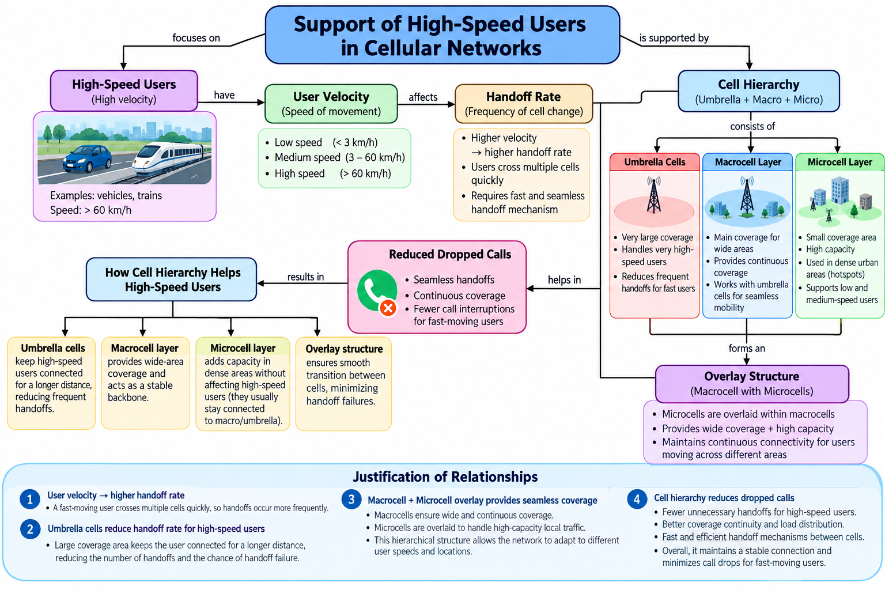

2. Velocity Classification and Handoff Mechanics
User mobility is broadly categorized into distinct speed tiers, each imposing different demands on the radio access network:

- Low Speed ($<3$ km/h): Typical of pedestrians; characterized by long dwell times within individual cells.

- Medium Speed ($3-60$ km/h): Associated with urban transit and local vehicle traffic.

- High Speed ($>60$ km/h): Associated with highway travel and high-speed rail, where users cross multiple cell boundaries rapidly.

Impact on Handoff Rate: A user's velocity directly affects the handoff rate (the frequency of cell changes). As velocity increases, the dwell time inside a cell decreases proportionally, leading to a surge in handoff requests. Without specialized routing, this high handoff frequency introduces severe signaling overhead and increases the probability of handoff failure and dropped calls.

3. Hierarchical Cell Structure and Overlay Design
To accommodate diverse user velocities and traffic densities, cellular networks implement a hierarchical structure combining three distinct layers:

- Umbrella Cells: Characterized by very large coverage footprints, these cells are engineered specifically to handle extremely high-speed users over extended distances, thereby reducing the frequency of handoffs.

- Macrocell Layer: Serves as the stable wide-area coverage backbone of the cellular architecture, operating alongside umbrella cells to ensure continuous mobility support.

- Microcell Layer: Covers small geographical areas with high traffic capacity, deployed primarily in dense urban hotspots to support low- and medium-speed users.

Macrocell-Microcell Overlay Structure: Microcells are overlaid within the broader macrocell coverage area. This overlay design simultaneously achieves wide-area continuity and high local capacity, maintaining uninterrupted connectivity for users transitioning across different zones.

4. Assessment of Cell Hierarchy in Reducing Dropped Calls
The hierarchical cell structure mitigates call drops for fast-moving users through systematic traffic segmentation and mobility management:

- Elimination of Unnecessary Handoffs: By routing high-speed users through umbrella or macrocells, the network bypasses the microcell layer entirely, keeping fast users connected over longer distances and preventing frequent handoff triggers.

- Seamless Transitions: The overlay architecture ensures smooth transitions between tiers, minimizing signaling congestion and handover failures.

- Optimized Load Distribution: Slow-moving and stationary traffic is absorbed by high-capacity microcells, while fast-moving traffic is carried by the macro/umbrella backbone, maintaining overall network stability and reducing call interruptions.

5. Summary of Key Relationships
The operational effectiveness of the cellular hierarchy is justified by the following core principles:

- Velocity Drives Handoff Frequency: High user speed accelerates cell boundary crossings, directly increasing the handoff rate.

- Umbrella Cells Mitigate Handoff Overhead: Large coverage radii keep fast users connected longer, lowering handoff frequencies and failure risks.

- Overlay Balancing: Macrocells provide wide-area continuity while microcells absorb local traffic, enabling the network to dynamically adapt to varying user speeds.

- Reduction of Dropped Calls: Minimizing unnecessary handoffs for high-speed users ensures superior coverage continuity, efficient load balancing, and stable connections.

